**F20BC/F21BC – Lab**

**Lab sheet**

**Deep Learning II**

**Introduction**

In this section we will try to use deep learning to generate new texts and compose music! For instance, we could generate some texts based on the complete series of Sherlock Holmes or generate a new piece of Bach style music.

**Computing Facilities**

Many tasks in this lab can be completed by [Google Colab](https://colab.research.google.com/), but you can also use your own computer, MACS Linux environment, or MACS VM.

See more details on the “BIC Computing Facilities” document for how to access the above computing facilities.

**Software and Tools Required**

We will use Python+TensorFlow for this practical. Depending on which computing facility you are using, you may already have all software installed, so the following instructions may vary.

**Install TensorFlow and Python** <https://www.tensorflow.org/install/> TensorFlow is a deep learning library developed by Google. You are recommended to install TensorFlow by the “virtualenv” method or through Conda environment if you have Conda (Anaconda) on your own computer.

**Google Colab** Alternatively, you may consider using Google Colab, and in that case you don’t need to install Python and TensorFlow locally. However, bear in mind that the cloud-based framework may not be as flexible as local installation, and sometimes it is slow and has compatibility issues.

**GitHub:** Install Git (<https://github.com/>) and register a **free** account. GitHub may seem a bit complicated if you haven’t used them before, but here we just use part of its functionalities. Some may find GitHub Desktop (<https://desktop.github.com/>) is easier to use as it provides good UI interfaces.

You can start with the following article to understand how github and git works: <https://guides.github.com/activities/hello-world/>

**The RNN Code**

We will use the following multi-layer recurrent neural networks (LSTM, RNN) in python using TensorFlow:

<https://github.com/sherjilozair/char-rnn-tensorflow>

1. Clone the above repository to your local repository by using “git clone”:

<https://help.github.com/articles/cloning-a-repository/>

2. Try to generate some text based on the complete series of Sherlock Holmes using the above RNN code. To save some time, you don’t need to use the complete Sherlock Holmes texts, and you can use some simpler texts from anywhere you find online. The two basic commands are:

a. Training:



The above command will train your RNN from existing texts. You may need to replace “sherlock” with other corpus available.

b. Sampling (to obtain some texts):



Note that the training may take some time depending on your machine. After training, you will be able to use the trained RNN to generate some text.

If you use Google Colab, you will not need to install/use Python and Tensorflow on your local computer. At some point you may get the a Jupyter Notebook similar as follows.

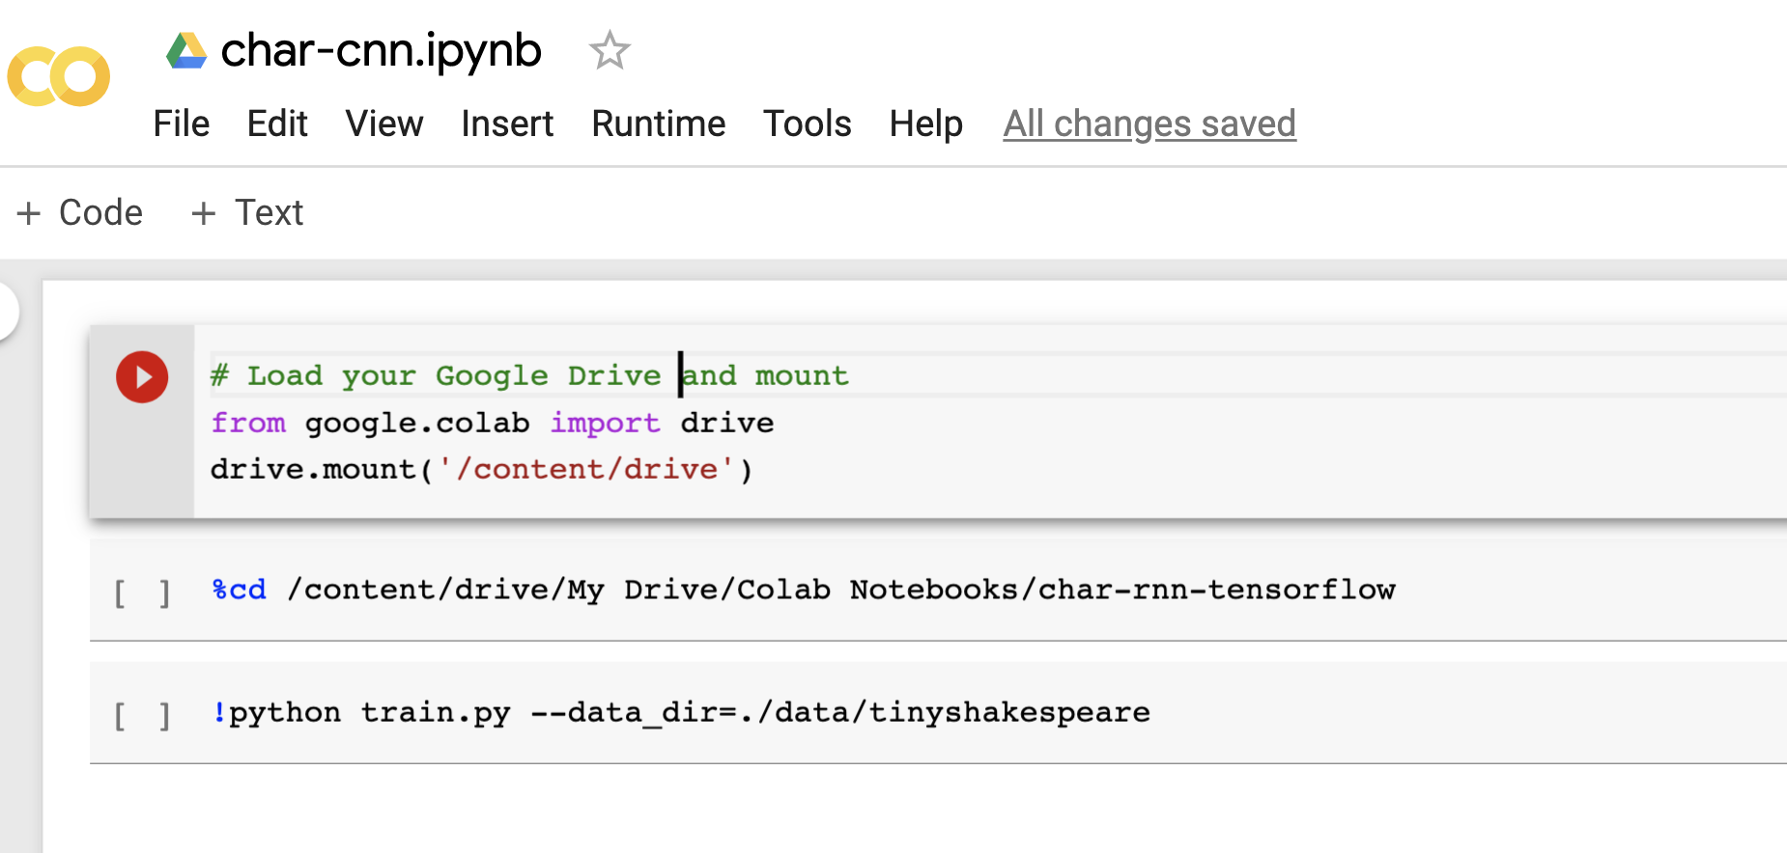

The basic idea is to mount your Google Drive to Colab, and run Python online. If anything goes wrong, you can reset the runtime environment by going to “Runtime”🡪”reset all runtimes”

**Going Further (optional, but strongly recommend)**

1. Writing the next book of Games of Throne

Read the following news from New York Post

<http://nypost.com/2017/08/29/artificial-intelligence-is-writing-the-next-game-of-thrones-book/>

Here is how it works:

<https://github.com/zackthoutt/got-book-6>

The idea is similar, and you could try it yourself. Follow the steps in the above code and see how far you could go.

Again, you may find using Google Colab (<https://colab.research.google.com/>) is a good way of running Jupiter Notebook.

2. **Composing music**: <https://maraoz.com/2016/02/02/abc-rnn/>

The basic idea is to represent music in the form of abc notes, and RNN is then used to learn and predict the abc sequences. To begin with, you could focus on Bach’s music by doing a refined search from the following URL:

<http://abcnotation.com/>

3. YOLO: <https://pjreddie.com/darknet/yolo/>

Background: We use YOLOV2 for one of our projects with Oxford and Middlesex: <http://www.mitime.org/EndoAI/index.htm>, and now YOLOV3 is also released.

4. Detectron2:

In the above same project, we are also using Detectron2: <https://github.com/facebookresearch/detectron2>

In particular, you can try the Colab Notebook as follows:

[Colab Notebook](https://colab.research.google.com/drive/16jcaJoc6bCFAQ96jDe2HwtXj7BMD_-m5)